Marketing's Impact on Forecast Accuracy

Martin Waugh
Colorado State University Global
MIS581: Business Intelligence and Data Analytics
Dr. Justin Bateh
10/04/2026

Abstract
Organizations depend on accurate demand forecasts, yet forecasting processes often rely on historical sales alone and leave marketing information unused. This study examined whether marketing-related variables are related to customer demand (Research Question 1) and whether adding them to a forecasting model improves forecast accuracy (Research Question 2). The M5 Forecasting Accuracy dataset, built by Walmart retail sales, contains no direct measures of marketing spending, so calendar events and price changes served as proxies. The study used a quantitative, deductive design. An ordinary least squares regression on more than 46 million observations tested the relationship between the proxies and daily unit sales. A comparison of Exponential Smoothing, an XGBoost model using historical demand only, and an XGBoost model with the marketing proxies, evaluated on 300 item-store series with the Weighted Root Mean Squared Scaled Error (WRMSSE) over a 28-day holdout period, tested forecast accuracy. Calendar events and price level had statistically significant relationships with demand, but the model explained little variation (R² = .023), and the effect of price changes reversed direction across product categories. Adding the proxies did not improve forecasts. Overall WRMSSE was nearly identical across models, and the enhanced model performed slightly worse than the baseline in Hobbies and Household. A variable can therefore be statistically significant in an explanatory model and still fail to improve a predictive one. Recommended next steps include testing price-change magnitude, event-type indicators, and rolling evaluation windows, and using direct marketing data where available.
Keywords: demand forecasting, marketing variables, XGBoost, forecast accuracy, M5 competition

Marketing's Impact on Forecast Accuracy
Organizations rely on forecasts to determine how much product to purchase, manufacture, and stock, making forecast accuracy essential to financial performance. Over-forecasting can create excess inventory and increase obsolescence risk, while under-forecasting can result in stockouts, lost sales, and lower customer satisfaction. Traditional forecasting methods rely primarily on historical sales data and time-series techniques to project future demand. While effective in stable environments, these approaches often fail to capture demand shifts caused by marketing activities such as promotions, advertising campaigns, pricing actions, and customer engagement initiatives. As a result, forecasts based solely on historical data may overlook important changes in purchasing behavior. The following discussion examines how marketing initiatives influence demand and why they are often excluded from the forecasting process.
Marketing activity has been shown to meaningfully influence customer purchasing behavior, sometimes causing a sales spike well beyond what a purely historical model would predict, followed by post-promotional dips as customers who stockpiled during the promotion delay future purchases. Despite this well-documented relationship, many supply chain organizations continue to build forecasts in relative isolation from their marketing counterparts. Marketing calendars, campaign spending, and customer engagement metrics reside in systems separate from the demand planning function, leaving valuable indicators of demand change available but often unused. This research focuses on this gap: the marketing function and the supply chain forecasting function often operate with limited shared visibility, even though the data each holds could meaningfully improve the other’s outcomes.
The specific problem this research addresses are not simply that marketing and supply chain functions often operate in silos, a disconnect already well documented in prior literature, but that limited evidence exists regarding how much incorporating marketing variables into a forecasting model improves forecast accuracy when using publicly available data. Forecasts built solely on historical sales data implicitly assume that future demand will follow past patterns, an assumption that breaks down whenever a promotion, advertising push, or pricing change is introduced. This can increase forecast errors, leading to excess inventory or stockouts, both of which have direct financial and customer service consequences for the organization.
Organizations increasingly have access to large volumes of operational, pricing, and promotional information, yet many forecasting processes continue to rely primarily on historical sales patterns. This creates an opportunity to evaluate whether marketing-related information can improve forecasting performance when incorporated into modern predictive models. This study uses the M5 Forecasting Accuracy dataset, which contains historical retail sales data as well as calendar and pricing information that serve as proxies for marketing activities, since the dataset does not include direct measures of marketing expenditures or campaign effectiveness. The study compares Exponential Smoothing against two XGBoost models, one trained on historical demand alone and one trained with the added marketing-related variables, to evaluate whether those variables improve forecast accuracy beyond historical-demand-only approaches. By examining both statistical relationships and forecast performance, this research seeks to determine whether marketing-related variables provide measurable value in demand forecasting.
Objectives
The primary objective of this study is to evaluate the extent to which marketing-related variables influence customer demand and whether those variables can be used to improve forecasting performance. Marketing-related variables are represented by calendar events and product pricing information available within the M5 Forecasting Accuracy dataset.
A second objective is to determine whether the inclusion of marketing-related variables produces measurable improvements in forecast accuracy compared with models that rely solely on historical demand information. To accomplish this, the study will compare traditional forecasting approaches, including Exponential Smoothing with machine learning approaches based on XGBoost.
Finally, this study seeks to determine whether any observed forecasting improvements are statistically significant and whether marketing-related variables provide practical value for organizational forecasting and supply chain decision-making.
Research Questions and Hypotheses
The literature suggests that marketing activities can influence customer purchasing behavior and demand patterns. However, limited research has examined whether marketing-related variables represented by publicly available calendar and pricing information can improve forecasting performance compared with models that rely solely on historical demand data. To address this gap, this study investigates two research questions.
Research Question 1: To what extent do marketing-related variables have a statistically significant relationship with customer demand?
- Null Hypothesis (H01): Marketing-related variables do not have a statistically significant relationship with customer demand.
- Alternative Hypothesis (H11): Marketing-related variables have a statistically significant relationship with customer demand.
Research Question 1 focuses on determining whether marketing-related information contributes to explaining variation in demand. Statistical testing will be conducted to evaluate whether the identified marketing-related variables demonstrate a significant relationship with sales patterns within the dataset.
Research Question 2: Does the inclusion of marketing-related variables improve demand forecast accuracy compared with models that rely solely on historical demand data?
- Null Hypothesis (H02): The inclusion of marketing-related variables does not improve demand forecast accuracy compared with models that rely solely on historical demand data.
- Alternative Hypothesis (H12): The inclusion of marketing-related variables improves demand forecast accuracy compared with models that rely solely on historical demand data.
Research Question 2 focuses on the practical forecasting value of marketing-related information. Forecast accuracy will be evaluated by comparing traditional forecasting models and machine-learning models developed both with and without marketing-related variables. Model performance will be measured using the Weighted Root Mean Squared Scaled Error (WRMSSE), and statistical testing will be used to determine whether any observed improvements are significant.
Literature Review
To address the research questions presented in this study, it is necessary to examine existing literature related to marketing activity, demand forecasting, machine learning forecasting methods, and forecast accuracy evaluation. The following review summarizes key findings from prior research and identifies the gap that this study seeks to address.
Marketing-Mix Variables and Demand Forecasting
This project sits at the intersection of marketing and demand forecasting, so relevant sources are not always confined to a single discipline. Polonsky and Waller (2019) explain that research questions spanning multiple fields often require drawing on literature that speaks indirectly rather than directly to the topic on hand, which is reflected in how the following discussion connects forecasting-focused studies with research centered more narrowly on marketing-mix variables. Prior research has established that marketing-mix variables carry meaningful predictive value for demand forecasting, providing an initial foundation for the assumption underlying this project’s hypothesis. Kumar, Shankar, and Aljohani (2020) proposed a big data driven demand forecasting framework that incorporated marketing-mix variables such as pricing and promotional spend, finding that these variables improved forecast performance when layered onto traditional historical-demand models. Their framework used aggregated retail data rather than item-level data, raising the open question of whether similar gains persist at the finer granularity used in this project. Abolghasemi, Hurley, Eshragh, and Fahimnia (2020) addressed a closely related problem, examining how systematic events, specifically sales promotions, disrupt demand patterns and complicate traditional forecasting techniques. Their work demonstrated that failing to account for promotional events introduces forecast bias, supporting this project’s decision to treat calendar events and price changes as measurable inputs. Together, these two studies establish that marketing-related variables are treated in prior literature as forecasting inputs worth isolating and modeling directly, rather than as incidental data noise.
Machine Learning Approaches to Promotional Forecasting
A second body of literature addresses how machine learning methods specifically handle promotional and marketing-driven demand fluctuations, which is directly related to this project’s planned comparison between classical forecasting benchmarks and an XGBoost model. Ma, Fildes, and Huang (2016) examined SKU-level retail forecasting using high-dimensional promotional data and found that forecasting improvements from including promotional information varied substantially across product categories, with some categories benefitting significantly and others showing little to no improvement. This finding matters for this project because an aggregate accuracy metric alone may understate or overstate the value of marketing variables depending on how uniformly the effect applies across the dataset’s product hierarchy. Gür Ali and Gürlek (2020) took a related approach by developing an interpretable retail forecasting framework built around promotional scenarios rather than optimizing purely for accuracy. Their emphasis on interpretability reinforces this project’s interest in understanding which promotional or pricing variables drive any observed change, rather than treating the model as a black box. Most recently, Hewage, Perera, and Bandara (2026) compared gradient boosting and deep learning methods against similar base-lift models across the full promotional demand life cycle, including the often-overlooked post-promotional period, and found that machine learning methods performed only comparably to simpler established models in several scenarios. This is a useful caution for this project’s model tournament, since outperforming a historical baseline alone is not sufficient evidence; the enhanced model must also outperform simpler, established benchmarks to justify the added complexity.
The M5 Competition and Forecast Accuracy Evaluation
The final area of literature relevant to this project concerns the dataset and evaluation methodology being used. Makridakis, Spiliotis, and Assimakopoulos (2022) documented the results, findings, and conclusions of the M5 Accuracy Competition, which used the same Walmart sales dataset that forms the basis of this project. Their analysis established that item-level retail demand data of this kind is dominated by intermittent demand patterns, including a high proportion of zero-sales observations, which complicate forecasting methods calibrated on smoother demand series. This directly informed the decision to use the Weighted Root Mean Squared Scaled Error (WRMSSE) as this project’s accuracy metric, since it was purpose-built for these dataset characteristics and is comparable across the broader M5-related literature.
Collectively, the literature indicates that marketing activities can influence customer demand and that machine learning approaches frequently outperform traditional forecasting methods in complex demand environments. However, relatively little research has evaluated whether publicly available marketing-related proxy variables, such as calendar events and pricing information, can improve forecasting performance when actual marketing-spend data is unavailable. This study seeks to address that gap by evaluating both the statistical relationship between marketing-related variables and demand as well as their impact on forecast accuracy.
Research Design
This study employs a quantitative research methodology to examine the relationship between marketing-related variables and customer demand and to evaluate whether those variables improve demand forecast accuracy. According to Polonsky and Waller (2019), quantitative research is appropriate when research questions focus on measuring relationships and testing hypotheses using numerical data. This is important because both research questions in the current study require statistical evaluation rather than subjective interpretation. Rather than relying on interviews, surveys, or qualitative observations, this study analyzes historical sales data and forecasting results to measure the impact of marketing-related variables on demand prediction.
Methodology
The study uses a deductive research methodology in which hypotheses derived from existing literature are empirically tested using historical retail sales data. Polonsky and Waller (2019) explain that deductive research begins with theory and then uses data analysis to determine whether the theory is supported. This approach aligns well with the current study because prior literature suggests that marketing activities can influence customer demand, yet uncertainty remains regarding whether those effects improve forecast accuracy when using publicly available data sources.
Previous research by Gür Ali and Gürlek (2020) found that promotional activities can alter customer purchasing patterns and create demand fluctuations. Similarly, Kumar et al. (2020) highlighted the value of incorporating marketing-related information into forecasting processes. These findings provide a theoretical basis for examining whether marketing-related variables contribute to demand forecasting performance and justify the development of the study’s hypotheses.
Secondary data obtained from the M5 Forecasting Accuracy dataset serves as the primary source of information for the study. Polonsky and Waller (2019) note that secondary data allows researchers to analyze large datasets efficiently while reducing the time and cost associated with primary data collection. This is particularly important because the M5 dataset contains thousands of product-level observations across multiple years, providing sufficient information to evaluate forecast performance under a variety of demand conditions.
The research design combines explanatory and predictive analytics. Explanatory analysis is used to examine whether marketing-related variables demonstrate a statistically significant relationship with customer demand, while predictive analysis is used to evaluate the impact of those variables on forecast accuracy. Makridakis et al. (2022) emphasize the value of comparing forecasting approaches using objective performance measures rather than assuming a more sophisticated model will perform better. This perspective is reflected in the current study through the comparison of traditional forecasting techniques and machine-learning models, allowing the data to determine whether the added complexity of marketing-related variables improves forecasting outcomes.
Methods
The study utilizes the M5 Forecasting Accuracy dataset to examine the relationship between marketing-related variables and customer demand as well as the impact of those variables on forecast accuracy. The dataset contains historical retail sales transactions, calendar information, and product pricing data. Calendar events and product pricing information are used as proxy measures of marketing activity because direct measures of advertising expenditures, campaign performance, and promotional spending are not available within the dataset. While these proxies do not fully capture all marketing activity, they provide a practical means of evaluating whether marketing-related information contributes to forecasting performance.
According to Polonsky and Waller (2019), researchers should carefully align data collection and analysis methods with their research objectives. This is important because the current study investigates both the statistical relationship between marketing-related variables and demand and the practical forecasting value of incorporating those variables into predictive models. Consequently, multiple analytical techniques are used to address the study's two research questions.
Prior to model development, the sales, calendar, and pricing files will be merged to create a unified analytical dataset. Data preparation will include validation of calendar and pricing variables, treatment of missing values, and verification of zero-sales observations. The M5 dataset contains many intermittent-demand products with extended periods of zero sales. This is important because improper treatment of these observations could distort forecast accuracy measurements and produce misleading results.
To address Research Question 1, regression analysis will be used to evaluate whether marketing-related variables demonstrate a statistically significant relationship with customer demand. Independent variables will include calendar-event indicators and pricing-related measures, while sales volume will serve as the dependent variable. Statistical significance testing will be used to determine whether these variables explain meaningful variation in demand patterns. Polonsky and Waller (2019) state that statistical analysis enables researchers to evaluate relationships among variables and assess whether observed effects are likely due to chance. This approach directly supports the first research question because it quantifies the relationship between marketing-related variables and customer demand.
To address Research Question 2, three forecasting approaches will be evaluated. The first benchmark model will utilize Exponential Smoothing, which forecasts future demand by applying greater weight to more recent observations. Abolghasemi et al. (2020) note that traditional forecasting methods continue to provide strong performance in many business forecasting applications. This makes them appropriate benchmark models against which more advanced approaches can be evaluated.
The second model will utilize XGBoost trained exclusively on historical-demand information. This model serves as the machine-learning baseline and allows forecast improvements associated with marketing-related variables to be isolated. The third model will utilize XGBoost trained using both historical-demand data and marketing-related variables derived from calendar events and pricing information. Kumar et al. (2020) found that integrating additional demand drivers can improve forecasting performance under certain conditions. This makes the comparison between the baseline and enhanced XGBoost models particularly important because it directly evaluates the contribution of marketing-related information.
Forecast performance will be evaluated using the Weighted Root Mean Squared Scaled Error (WRMSSE) metric, which was developed as the primary evaluation measure for the M5 Forecasting Accuracy Competition. WRMSSE accounts for differences in product importance and sales volume across hierarchical retail forecasting structures. This is important because the study seeks to evaluate forecast performance in a manner consistent with the intended design of the dataset rather than relying solely on traditional error metrics.
Finally, statistical significance testing will be used to determine whether observed forecast improvements are meaningful rather than the result of random variation. Makridakis et al. (2022) emphasize the importance of objectively evaluating forecasting methods based on demonstrated performance rather than model complexity alone. This principle aligns with the purpose of the current study because the research seeks to determine whether the addition of marketing-related variables creates measurable and statistically significant improvements in forecast accuracy.

Limitations
Every research study contains limitations that should be considered when interpreting results. Polonsky and Waller (2019) note that acknowledging limitations helps establish appropriate boundaries for research conclusions. This is important because the current study evaluates forecasting performance using publicly available retail data rather than direct measures of marketing activity.
The primary limitation is the absence of actual marketing metrics within the M5 Forecasting Accuracy dataset. Marketing influence is represented through calendar events and product pricing information, which serve as proxy variables rather than direct measures of advertising, promotions, or campaign effectiveness. This is important because weak statistical relationships or limited forecasting improvements may reflect limitations of the selected proxies rather than the absence of a true marketing effect.
A second limitation is the use of a single retail dataset. Consumer behavior, promotional effectiveness, and demand patterns may differ across industries and organizations. As a result, findings from this study may not be fully generalizable beyond the retail environment represented in the M5 dataset.
Finally, forecasting models rely on historical data and assume that past relationships provide insight into future demand patterns. Changes in market conditions, competitive actions, or customer preferences may reduce the applicability of historical relationships over time. Consequently, forecast performance observed in this study may not fully reflect future forecasting conditions.

Ethical Considerations
Researchers have an ethical responsibility to report findings accurately and transparently. Polonsky and Waller (2019) emphasize the importance of maintaining research integrity throughout the research process. This is important in this study because the results may be used to support business forecasting and decision-making activities.
One ethical consideration involves the objective reporting of results. The study will report findings regardless of whether the results support the hypotheses. This is important because selectively reporting favorable outcomes could misrepresent the effectiveness of marketing-related variables and reduce the credibility of the research.
A second ethical consideration involves transparency regarding the use of proxy variables. The M5 dataset does not contain direct measures of marketing activity, so calendar events and pricing information are used as proxies. Clearly communicating this limitation is important because readers should understand the distinction between actual marketing metrics and the variables available for analysis.
Finally, the study will use publicly available data and will document the data preparation, modeling, and evaluation processes. This is important because transparency and reproducibility allow other researchers to evaluate, replicate, and validate the findings.
Data Security and Privacy Considerations
The M5 dataset is publicly available and contains no personal identifiable information, privacy risks are minimal. However, researchers still have the responsibility to maintain data integrity and secure storage practices to prevent unauthorized modifications of analytical datasets. Using publicly available, de-identified data reduces privacy concerns while still requiring careful stewardship to ensure reproducibility and accuracy of results.
Transition to Findings
This study seeks to address a gap in the forecasting literature by evaluating whether marketing-related variables improve forecast accuracy and provide meaningful insight into customer purchasing behavior. Existing research demonstrates that marketing activities can influence demand and that machine-learning approaches often outperform traditional forecasting methods under certain circumstances. However, limited research has examined whether publicly available marketing-related proxy variables can improve forecasting performance when direct marketing metrics are unavailable.
The research design presented in this paper provides a structured approach for evaluating both the statistical relationship between marketing-related variables and customer demand as well as their impact on forecast accuracy. The following sections present the findings from this analysis, compare the forecasting models described above, and evaluate the study’s hypotheses based on the results obtained.
Findings
The analytical dataset was constructed by merging the M5 sales, calendar, and pricing files into a single long-format table, with each row representing one product at one store on one day. Rows representing periods before an item was introduced at a given store were removed, since a missing price in these records reflected the item not yet being stocked rather than a genuine zero-demand observation. This left a working dataset of over 46 million observations spanning January 2011 through April 2016. Figure 1 displays total daily unit sales across the full dataset over this period, showing a clear upward trend, repeating weekly and annual seasonal cycles, and five distinct single day drops to zero, corresponding to Walmart’s annual Christmas Day closure. This pattern is consistent with characteristics of the M5 dataset documented by Makridakis et al. (2022), providing a useful check that the merged dataset behaved as expected before modeling began.
Figure 1
Total Daily Unit Sales Across All Products and Stores (2011-2016)
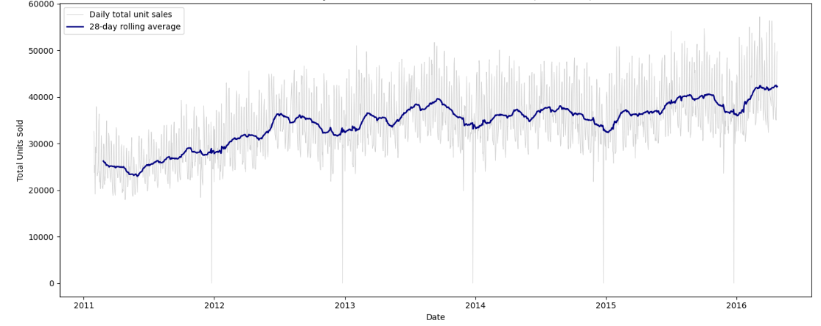
Note. Created by the author in Jupyter Notebook, based on M5 Forecasting – Accuracy dataset (Makridakis et al., 2022).
Research Question 1 Findings

To address Research Question 1, an ordinary least squares regression evaluated the relationship between the marketing-related variables (a calendar-event indicator and a price change indicator) and daily unit sales, with product price included as a control variable. Table 1 presents the pooled regression results.

Table 1
Pooled Regression Results for Research Question 1
Variable | Coefficient | p
Constant | 2.2753 | < .001
has_event | −0.0689 | < .001
price_change | 0.0177 | .248
sell_price | −0.1911 | < .001
R² | .023
Note. N = 46,027,957. Created by the author in Jupyter Notebook, based on M5 Forecasting – Accuracy dataset (Makridakis et al., 2022).
The overall model was statistically significant, F(3, 46,027,953) = 357,900, p < .001, though an R² of .023 indicates these variables explain only a small proportion of the variation in daily demand. Because the p-values for has_event and sell_price fell below the .05 threshold, the null hypothesis (H01) is rejected for these two variables. Because the p-value for price_change (.248) exceeds the .05, the null hypothesis fails to be rejected for this variable in the pooled model. Given the sample size involved, a regression by product category was also conducted to check whether this pooled result was masking category-specific effects. Table 2 presents these results.
Table 2
Regression Results by Product Category for Research Question 1
Category | has_event | price_change | sell_price | R²
Foods | −0.0735*** | −0.2733*** | −0.3866*** | .020
Hobbies | −0.0641*** | 0.3837*** | −0.0489*** | .011
Household | −0.0664*** | −0.0059 | −0.1276*** | .035
Note. Values are OLS regression coefficients. ***p < .001. price_change was not statistically significant for Household (p = .727). Created by the author in Jupyter Notebook, based on M5 Forecasting – Accuracy dataset (Makridakis et al., 2022).
Figure 2 visualizes the has_event and price_change coefficients across all three categories.
Figure 2
RQ1 Regression Coefficients by Product Category
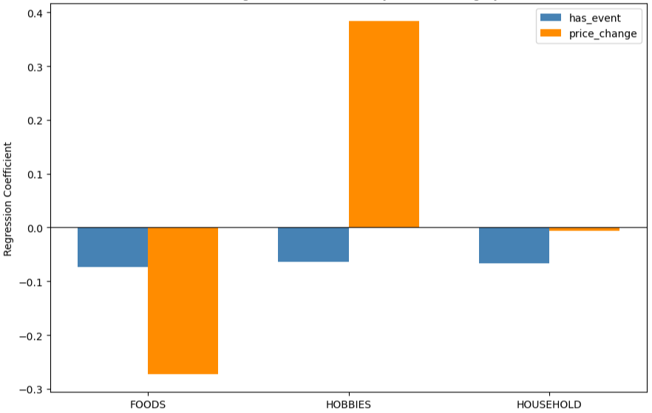
Note. Created by the author in Jupyter Notebook, based on M5 Forecasting – Accuracy dataset (Makridakis et al., 2022).
For has_event and sell_price, the null hypothesis is rejected in all three categories, with p-values below .001 in every case. For price_change, the null hypothesis is rejected in Foods and Hobbies, but fails to be rejected in Household (p = .727). Notably, the direction of the price_change coefficient differs between Foods (negative) and Hobbies (positive), which explains why the pooled model showed no significant effect for this variable: the two categories’ effects were pulled in opposite directions and largely canceled out when combined.

Research Question 2 Findings
To address Research Question 2, a random sample of 300 item-store series (100 from each category) was drawn, with the final 28 days of the dataset held out as a test period consistent with the M5 competition’s evaluation convention. Three forecasting approaches were compared: an Exponential Smoothing benchmark, an XGBoost model trained on historical demand features only, and an XGBoost model trained on the same historical features plus the marketing-related variables. Each model’s 28-day forecast was evaluated using WRMSSE. Table 3 presents these results.
Table 3
WRMSSE by Model and Product Category
Category | Exponential Smoothing | XGBoost Baseline | XGBoost Enhanced
Overall | 0.8225 | 0.8246 | 0.8247
Foods | 0.8727 | 0.8729 | 0.8700
Hobbies | 0.7617 | 0.7552 | 0.7582
Household | 0.7735 | 0.7854 | 0.7894
Note. Lower WRMSSE values indicate better forecast accuracy. WRMSSE = Weighted Root Mean Squared Scaled Error. Created by the author in Jupyter Notebook, based on M5 Forecasting – Accuracy dataset (Makridakis et al., 2022).
The three approaches performed almost identically overall, with WRMSSE values of 0.8225 for Exponential Smoothing, 0.8246 for the XGBoost baseline, and 0.8247 for the enhanced XGBoost model. Differences by category were also small. Exponential Smoothing recorded the lowest WRMSSE overall and in Household, the XGBoost baseline recorded the lowest in Hobbies, and the enhanced model recorded the lowest only in Foods. Figure 3 presents the same values graphically.
Figure 3
Model Comparison: WRMSSE by Model and Product Category
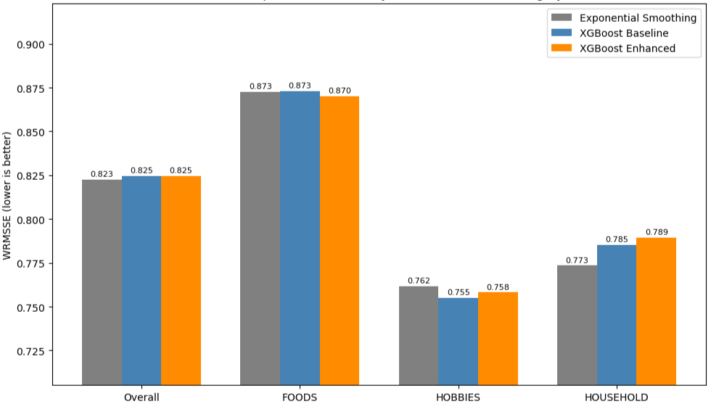
Note. Created by the author in Jupyter Notebook, based on M5 Forecasting – Accuracy dataset (Makridakis et al., 2022).
To formally test the null hypothesis that no difference exists between the baseline and enhanced models, a Wilcoxon signed-rank test was conducted on the 300 matched pairs of per-series RMSSE scores. A non-parametric test was selected because a Shapiro-Wilk test confirmed the paired differences were not normally distributed (p<.001). Figure 4 shows one example series’ actual demand against both models’ forecasts.
Figure 4
28-Day Forecast Comparison: Example Series
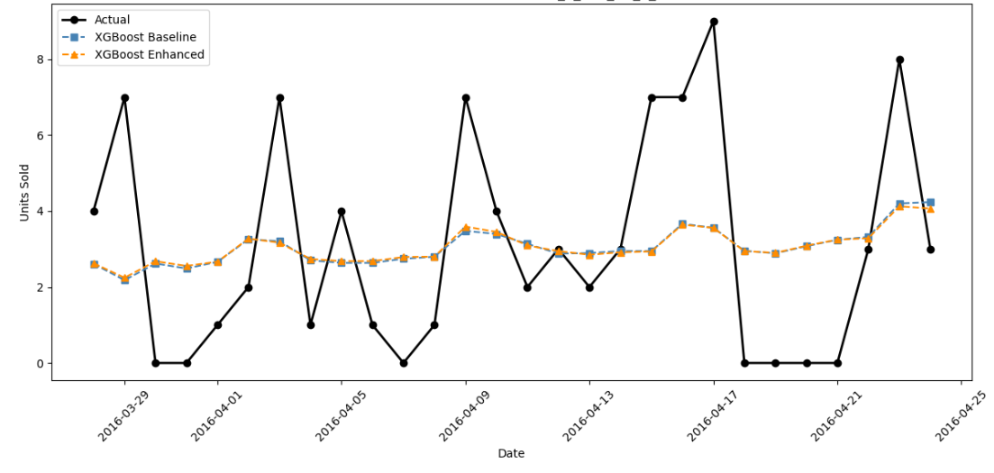
Note. Actual and forecast unit sales for series FOODS_1_173_CA_1 over the 28-day test period. Created by the author in Jupyter Notebook, based on M5 Forecasting – Accuracy dataset (Makridakis et al., 2022).
Pooled across all 300 series, the Wilcoxon test statistic was 15,603 with p<.001. Because this p-value is below .05, the null hypothesis (H02) is rejected at the pooled level; a statistically significant difference does exist between the two models. The enhanced model’s RMSSE was higher than the baseline for 181 of the 300 series, with a mean difference of +0.0083. Table 4 and Figure 5 break this test down by category.
Table 4
Wilcoxon Signed-Rank Test Results by Category
Category | Series Improved | Wilcoxon Statistic | p
Foods | 48/100 | 2,326.0 | .494
Hobbies | 39/100 | 1,563.0 | < .001
Household | 32/100 | 1,395.0 | < .001
Note. Series Improved is the number of series, out of 100 per category, for which the enhanced model had a lower RMSSE than the baseline model. Wilcoxon statistics and p values come from signed-rank tests on the paired per-series RMSSE scores. Created by the author in Jupyter Notebook, based on M5 Forecasting – Accuracy dataset (Makridakis et al., 2022).
Figure 5
Distribution of Per-Series RMSSE Differences by Category
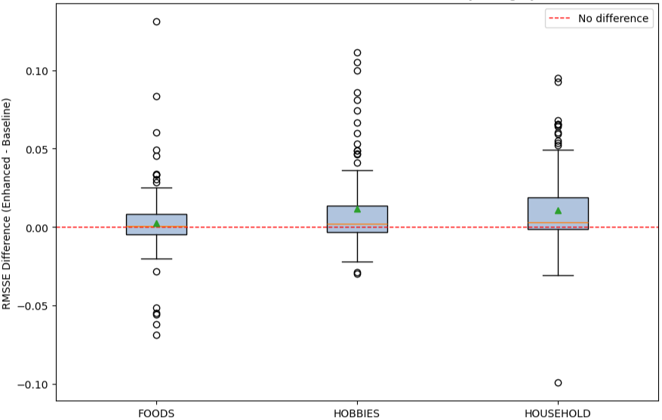
Note. Each box shows the interquartile range, the orange line shows the median, and the green triangle shows the mean. Circles are individual series outside the whiskers. The dashed red line marks no difference between models; values above zero mean the enhanced model had higher error than the baseline. Created by the author in Jupyter Notebook, based on M5 Forecasting – Accuracy dataset (Makridakis et al., 2022).
In Foods, the p-value of .494 exceeds .05, so the null hypothesis fails to be rejected; no statistically significant difference was found between the two models in this category. In Hobbies (p = .0009) and Household (p = .0001), the p-values fall below .05, so the null hypothesis is rejected in both categories; a statistically significant difference does exist between the models, with the enhanced model showing higher RMSSE values than the baseline for the majority of series in both categories.
Discussion
The Research Question 1 findings indicate that a statistically detectable relationship exists between the tested marketing-related variables and customer demand, though this relationship explains only a small share of the total demand variation, with R² values below .04 in every version of the model. This points to other unmeasured factors, most plausibly store-level effects, individual product demand cycles, and recent sales history, as the larger drivers of variation in this dataset, none of which the RQ1 regression isolated. It also raises a question about how these variables were measured: price_change here was defined as a binary flag indicating whether a price changed at all, with no information about the size or direction of that change. A continuous variable capturing the magnitude of a price change, along with separate indicators for each of the four calendar-event types (National, Religious, Cultural, Sporting) rather than one pooled has_event, would be reasonable additions for future testing on this dataset.
The Research Question 2 findings are more complex than a single pooled result would suggest. In Foods, the data did not provide evidence of a difference between the baseline and enhanced models. In Hobbies and Household, the data did provide evidence of a difference, but that difference ran opposite to what would have been needed to demonstrate a forecasting benefit. The enhanced model’s error was higher, not lower, than the baseline in both categories. This pattern is consistent with Hewage et al. (2026), who found that machine learning methods incorporating promotional information performed only comparably to simpler models in several scenarios rather than consistently outperforming them. A plausible explanation is that binary marketing flags with no directional or magnitude information introduce noise rather than useful signal into a recursive 28-day forecast, where small early errors compound forward through the lag-based features used in later prediction steps. A particularly notable disconnect appears in Hobbies, where price_change carried a strong, statistically significant relationship with demand in the Research Question 1 regression, yet the enhanced model performed worse than the baseline once the variable was added. This shows that a variable’s statistical significance in an explanatory model does not guarantee it will improve a predictive model’s accuracy, a distinction worth carrying forward into any future forecasting work on this or a similar dataset.
Hypothesis Outcomes
The two research questions produced different hypothesis outcomes, and the combined picture is more informative than either test alone. For Research Question 1, the null hypothesis (H01) was rejected for has_event and sell_price in the pooled regression and in every product category, so the data support the alternative hypothesis (H11) that these variables have a statistically significant relationship with demand. For price_change, H01 was not rejected in the pooled model or in Household, but it was rejected in Foods and Hobbies, where the coefficients pointed in opposite directions. The alternative hypothesis was therefore supported for the relationship question, although the very small R² values show that the relationship is weak in practical terms.
For Research Question 2, the Wilcoxon signed-rank test rejected the null hypothesis of no difference between the baseline and enhanced models at the pooled level, but the difference favored the baseline. Because the alternative hypothesis (H12) states that marketing-related variables improve forecast accuracy, a significant difference in which the enhanced model produced higher error cannot count as support for it. The alternative hypothesis was therefore not supported, and the claim in H02 that the added variables do not improve accuracy was consistent with the evidence. This outcome still says something useful about the data. Calendar events and binary price-change flags have a measurable link to demand, but they did not give the XGBoost model information it could turn into better 28-day forecasts, which suggests that the proxies, rather than marketing influence itself, are the most likely point of weakness.
Limitations of the Findings
Several limitations became clear once the analysis was complete. First, the 300-series sample, although drawn evenly across the three categories, is a small share of the full M5 hierarchy, so each category-level Wilcoxon test rests on only 100 series. Second, every model was evaluated over one 28-day window at the end of the data, which means the results could differ in other seasons or during different promotional periods. Third, the enhanced model forecasts recursively, so any weakness in the binary marketing flags can compound across the forecast horizon. Fourth, the regression for RQ1 used more than 46 million observations, which makes even very small effects statistically detectable, so the low R² values are a more useful guide to practical importance than the p-values. These limitations do not undermine the central findings, but they define how far it can be pushed. A different sample, evaluation window, or forecast horizon could produce different category rankings, which is the one reason the future research directions below emphasize rolling evaluation and larger samples.
Conclusion
This study examined whether marketing-related variables, represented through calendar events and pricing information, hold a measurable relationship with customer demand and whether adding them meaningfully improves forecast accuracy. The data showed a real but modest relationship between these variables and demand, with effects that differed substantially across product categories rather than acting uniformly. The data did not show a forecast benefit from adding these variables to an XGBoost model: performance was statistically indistinguishable from baseline in one category and significantly worse in the other two. Together, these results suggest that publicly available calendar and pricing data are not a reliable input for improving item-level forecast accuracy, even though they carry some explanatory value on their own.
Recommendations
Based on these findings, organizations considering the use of calendar or pricing signals in their own demand forecasting processes should be cautious about assuming that any measurable statistical relationship will translate into a forecasting improvement, particularly when that relationship is represented as a simple binary indicator. Before implementing marketing-related variables into a production forecasting model, organizations should test the variables directly against a held-out forecasting period, as done in this study, rather than relying on regression significance alone to justify their inclusion. For future research on this dataset, several directions appear promising. Testing a continuous price-change magnitude variable in place of the binary flag used here, and testing category-specific indicators for each calendar-event type rather than a single pooled event flag, would both provide a richer, more informative signal than the binary variables tested in this study. Aggregating demand to a monthly level before forecasting also represents a promising direction, since it would reduce the number of recursive forecasting steps from 28 to roughly one, potentially limiting the error compounding that appears to have contributed to the enhanced model’s weaker daily performance, while also aligning more closely with how many organizations actually structure their planning cycles. Organizations with access to true marketing expenditure or campaign-level data, rather than the calendar and pricing proxies necessitated by this dataset, would also be well positioned to test whether the pattern found here is specific to these particular proxy variables or reflects a more general limitation of adding marketing signals to item-level demand forecasts.
Future Research
Several extensions would build directly on this study. First, a longitudinal design would track how the effects of calendar events and price changes change over time. The M5 data span just over five years, from January 2011 through April 2016, so a rolling-origin evaluation that repeats the model comparison across many forecast windows, rather than a single 28-day window, would show whether the weak and inconsistent results found here are stable or depend on the period tested. Second, repeating the analysis with different populations, such as other retailers, regions, or industries, would test whether the category patterns generalize, and a larger stratified sample of series would tighten the category-level comparisons. Third, variables that were not considered in this study, including competitor actions, store-level conditions, and customer segments, could be added to see whether they explain demand that the calendar and price proxies miss. Finally, combining quantitative results with qualitative input from marketing and demand planning staff about how promotions were run would provide a form of triangulation that a single public dataset cannot offer, and it would help show whether the proxies used here describe real marketing activity.
References
Abolghasemi, M., Hurley, J., Eshragh, A., & Fahimnia, B. (2020). Demand forecasting in the presence of systematic events: Cases in capturing sales promotions. International Journal of Production Economics, 230, Article 107892. https://doi.org/10.1016/j.ijpe.2020.107892
Gür Ali, Ö., & Gürlek, R. (2020). Automatic interpretable retail forecasting with promotional scenarios. International Journal of Forecasting, 36(4), 1389–1406. https://doi.org/10.1016/j.ijforecast.2020.02.003
Hewage, H. C., Perera, H. N., & Bandara, K. (2026). Enhancing demand forecasting in retail: A comprehensive analysis of sales promotional effects on the entire demand life cycle. Journal of Forecasting, 45(1), 293–315. https://doi.org/10.1002/for.70039
Kumar, A., Shankar, R., & Aljohani, N. R. (2020). A big data driven framework for demand-driven forecasting with effects of marketing-mix variables. Industrial Marketing Management, 90, 493–507. https://doi.org/10.1016/j.indmarman.2019.05.003
Ma, S., Fildes, R., & Huang, T. (2016). Demand forecasting with high dimensional data: The case of SKU retail sales forecasting with intra- and inter-category promotional information. European Journal of Operational Research, 249(1), 245–257. https://doi.org/10.1016/j.ejor.2015.08.029
Makridakis, S., Spiliotis, E., & Assimakopoulos, V. (2022). M5 accuracy competition: Results, findings, and conclusions. International Journal of Forecasting, 38(4), 1346–1364. https://doi.org/10.1016/j.ijforecast.2021.11.013
Polonsky, M. J., & Waller, D. S. (2019). Designing and managing a research project: A business student's guide (4th ed.). SAGE Publications.

